Business Question and Visualization Report

Date | 25 July 2026
Project Name | Global Ai in Education
Maximum Marks | 5 Marks

Business Questions and Visualizations

Q1: What are the overall AI adoption and usage metrics across the education ecosystem?
Visualization: A KPI Dashboard displaying key indicators such as School AI Adoption, Student AI Usage, Teacher AI Usage, Urban AI Usage, and other summary metrics.
Insight Provided: Provides a comprehensive snapshot of the current AI landscape in education, allowing decision-makers to quickly monitor performance, compare key metrics, and evaluate overall progress in AI adoption.

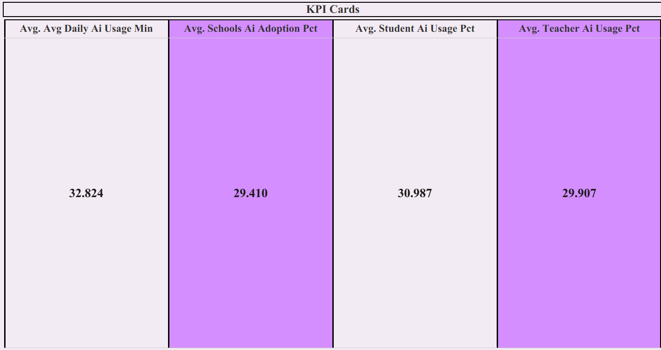

Q2: How does student AI usage change throughout the year?
Visualization: A Line Chart illustrating monthly trends in student AI usage.
Insight Provided: Reveals seasonal fluctuations in AI usage, helping educators and institutions understand peak usage periods and optimize AI-driven learning initiatives accordingly.
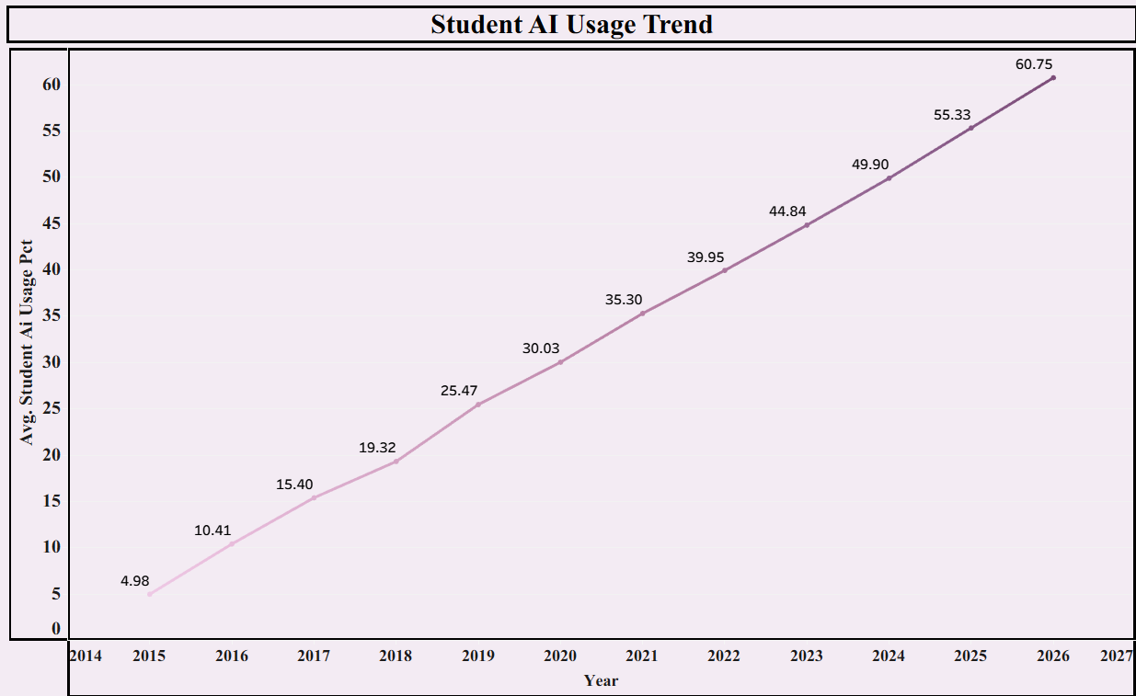

Q3: How does student AI usage differ across various geographic regions?
Visualization: A Horizontal Bar Chart comparing average student AI usage across different regions.
Insight Provided: Highlights regional differences in AI adoption among students, helping educational organizations identify high-performing regions and areas requiring additional AI awareness and resources.

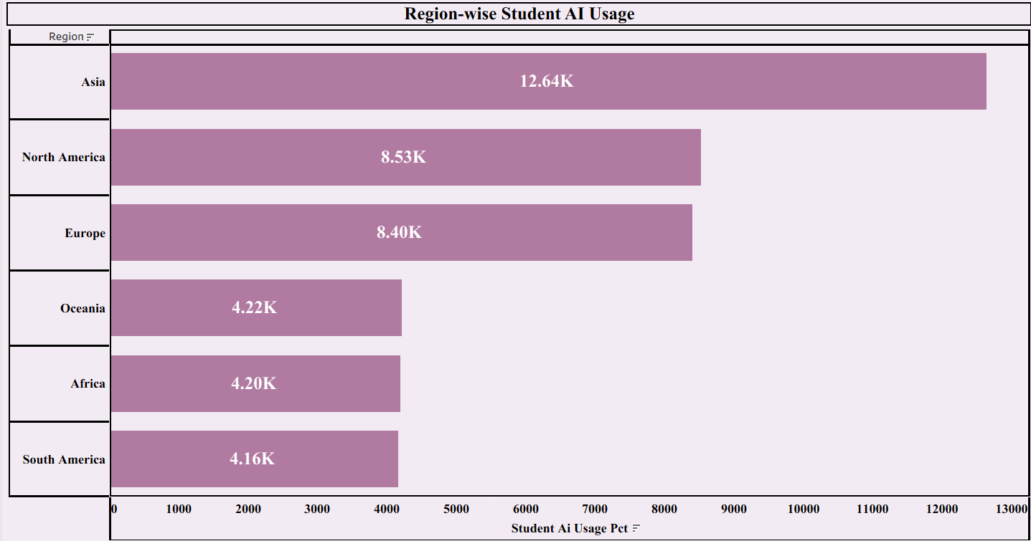

Q4: Which countries have achieved the highest levels of school AI adoption?
Visualization: A Filled World Map displaying school AI adoption rates across countries using colour intensity.
Insight Provided: Identifies countries leading in AI integration within schools while highlighting regions with lower adoption, supporting policymakers in planning targeted educational technology investments.

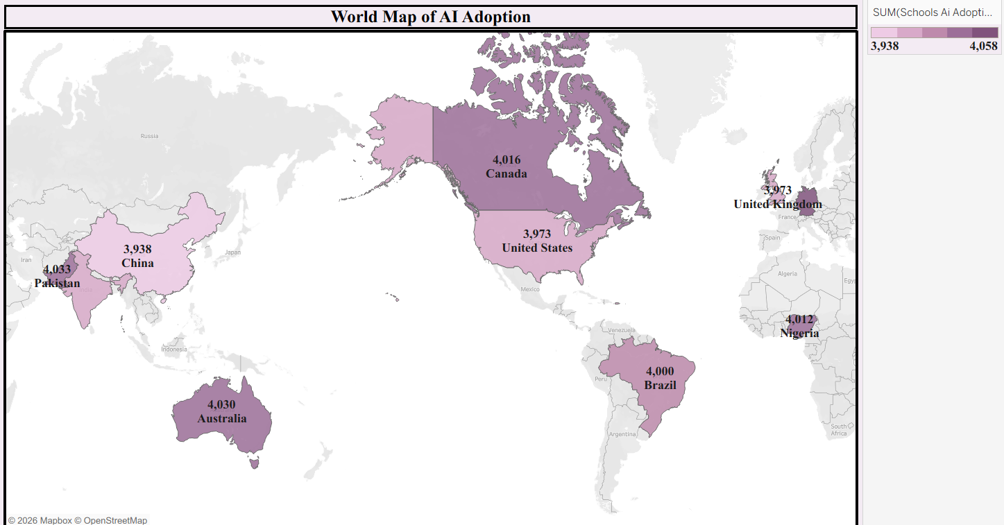

Q5: How has overall AI adoption in education evolved over the years?
Visualization: An Area Chart displaying the trend of overall AI adoption across multiple years, with the X-axis representing years and the Y-axis representing AI adoption percentage.
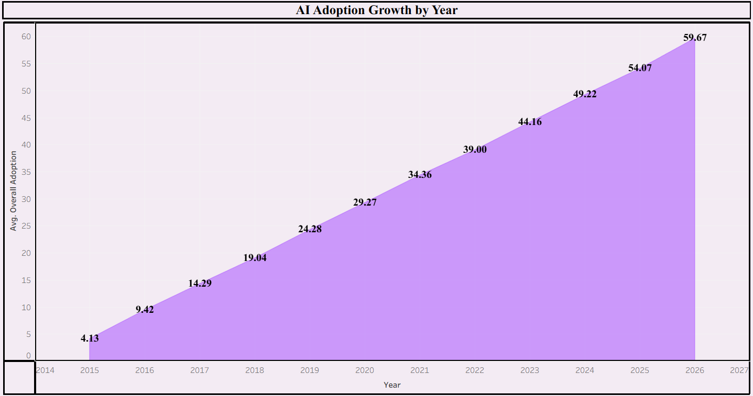
Insight Provided: Highlights the growth pattern of AI adoption over time, helping policymakers and educational institutions understand whether AI implementation is accelerating and identify periods of significant growth.

Q6: How does AI usage compare between students and teachers across different countries?
Visualization: A Side-by-Side Grouped Bar Chart comparing average AI usage by students and teachers for each country.
Insight Provided: Highlights adoption gaps between educators and learners, helping policymakers and institutions identify where teacher training and AI integration programs should be strengthened.

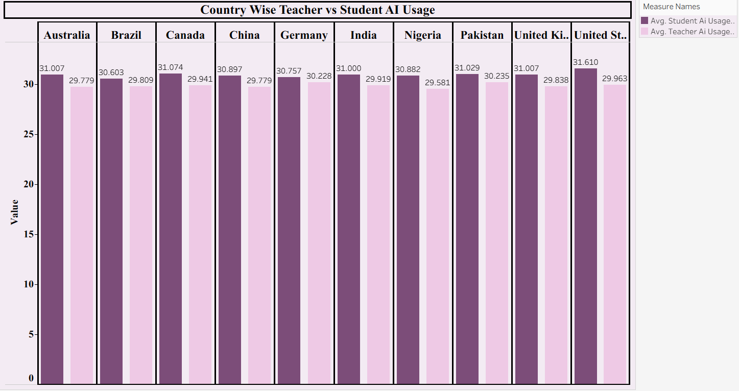

Q7: What is the global distribution of government AI policy implementation?
Visualization: A Pie Chart representing the proportion of countries categorized by their AI policy status (Strong, Moderate, and Weak).
Insight Provided: Provides a quick overview of government readiness and policy support for AI adoption, enabling stakeholders to assess regulatory maturity across different countries.

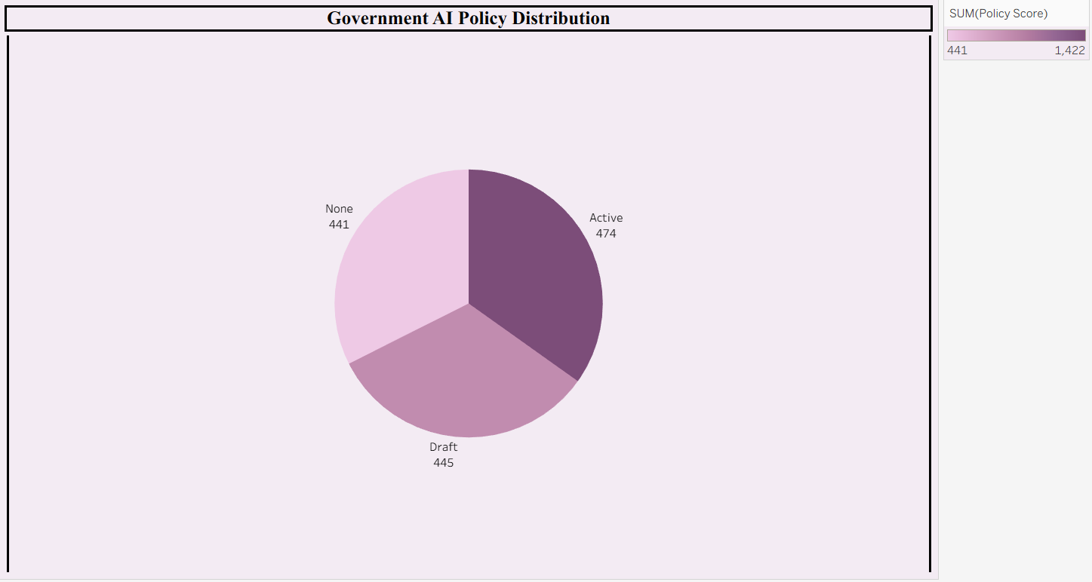

Q8: Which countries exhibit the largest disparity between urban and rural AI usage?
Visualization: A Grouped Bar Chart comparing urban and rural AI usage percentages for each country.
Insight Provided: Reveals the digital divide across countries, enabling governments and organizations to prioritize investments in rural AI infrastructure and digital literacy initiatives.
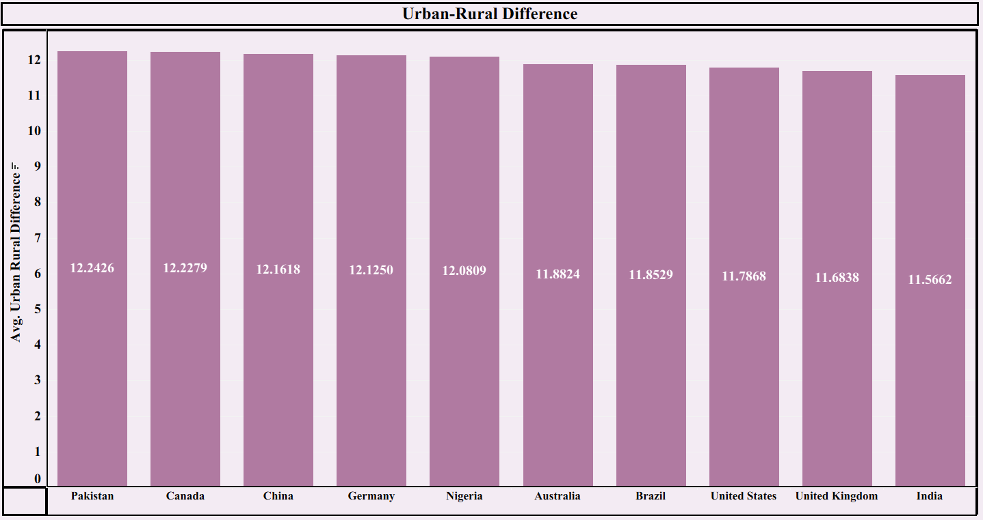

Q9: Which AI tools are most popular across different regions worldwide?
Visualization: A Stacked Bar Chart showing the distribution of the most commonly used AI tools across different regions.
Insight Provided: Demonstrates regional preferences for AI platforms, enabling AI companies and educational institutions to develop region-specific adoption strategies and improve localized AI solutions.

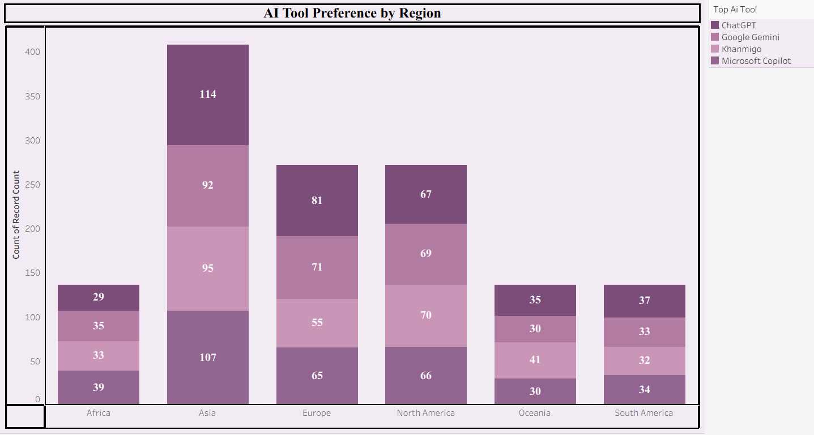

Q10: Which AI tools generate the highest average daily usage among users?
Visualization: A Bubble Chart where bubble size represents average daily AI usage and each bubble corresponds to a different AI tool.
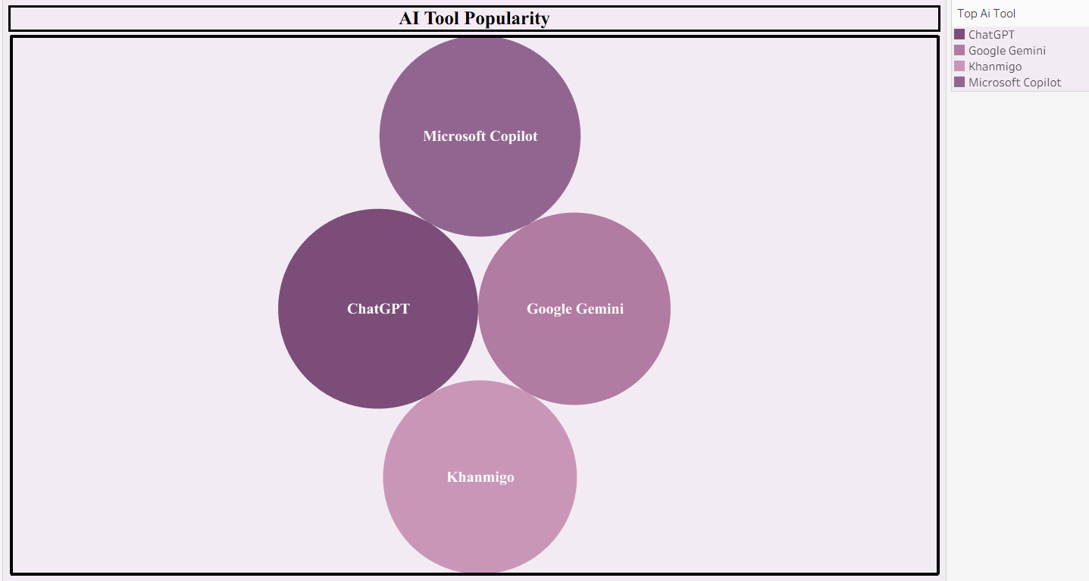
Insight Provided: Identifies the most frequently used AI tools, allowing developers and businesses to understand user preferences and focus on enhancing the most impactful platforms.

